BAWSC Membership Renewal Process
- Log into the site by entering in your email address assoicated with your previous year membership and passord. Note: if you forgot your password click on the “forgot passord” link and the system will send you an email with a link to reset your password.
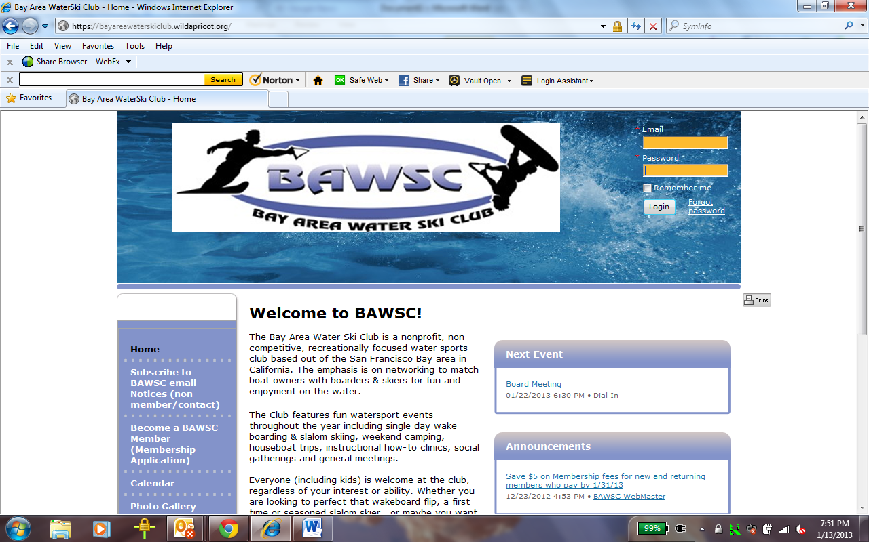

- Once you are logged in click on the “View Profile” button found in the upper right hand corner of the screen under your name. You should then see the “My Profile” screen as in the example below
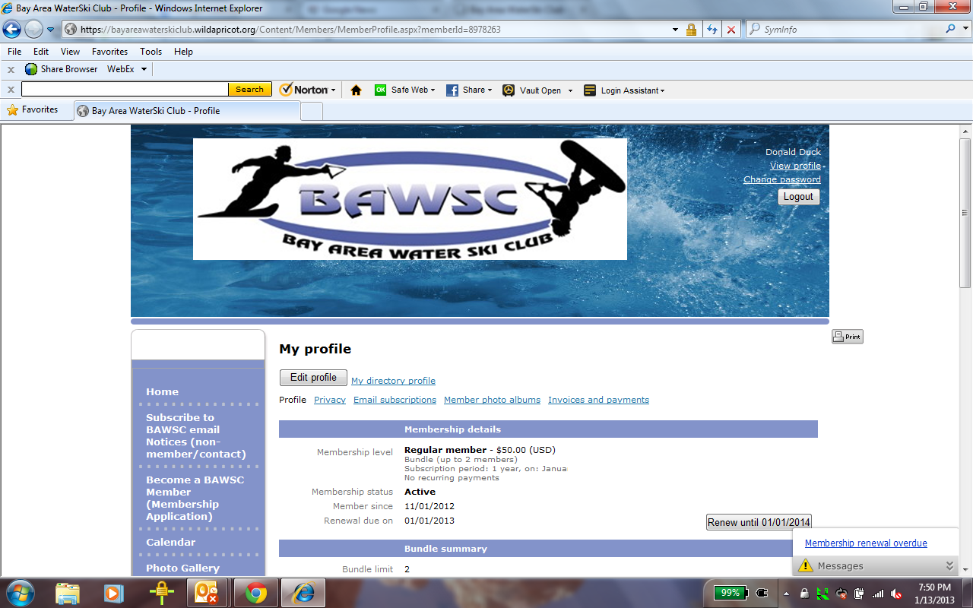

- Click on the “Renew until 01/01/2014” button to begin the renewal process. You should then see the “Membership Renewal” screen as seen below. Validate/update all the fields on the screen including clicking on and accepting the “Membership Waiver”
  - If you have dependents 18 and under associated with your account please make sure you update the Dependents section to reflect the correct age and names of your dependents. See the Membership Application Help Video for example how Brady Bunch would register with the club.
  - Once you have updated the form click on “Update and Next”
Note: If you don’t see the “Renew until 01/01/2014” button it is most likely because you are a bundle member (co-member) and need the bundle administrator (primary member) to execute the renewal process. As a bundle member (co-member) you can still update your profile and accept the club waiver.
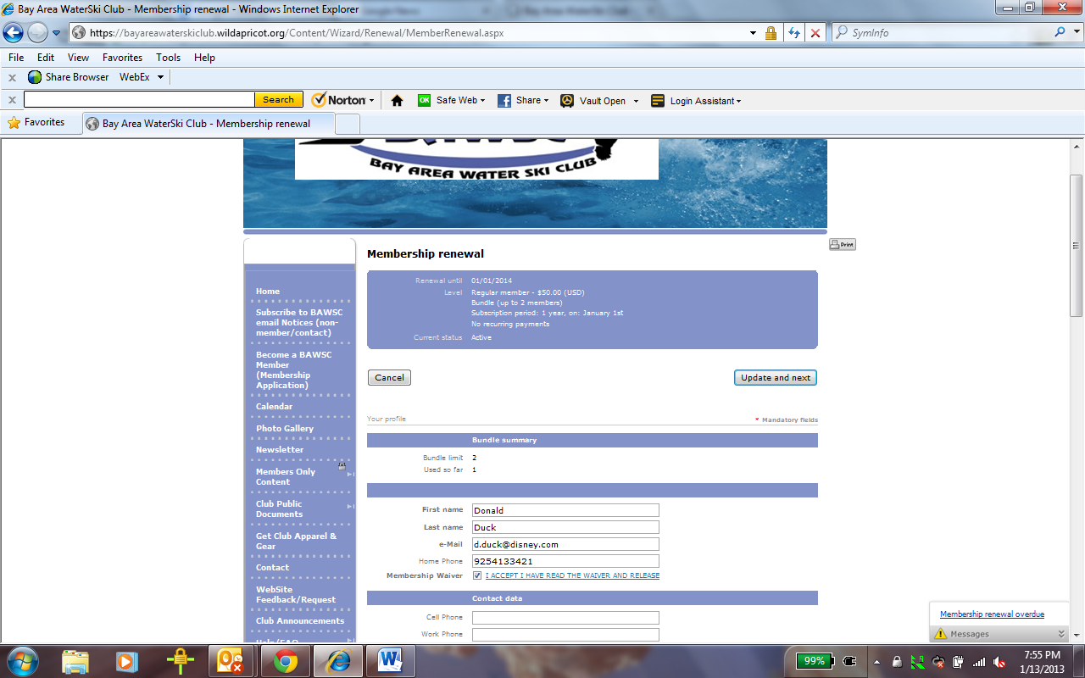

- You should then see a “Review and Confirm” screen where you should validate everything is correct including what you will owe for your 2013 membership. If everything looks correct click on the “Confirm and proceed with Payment” or the back button if you need to correct anything.
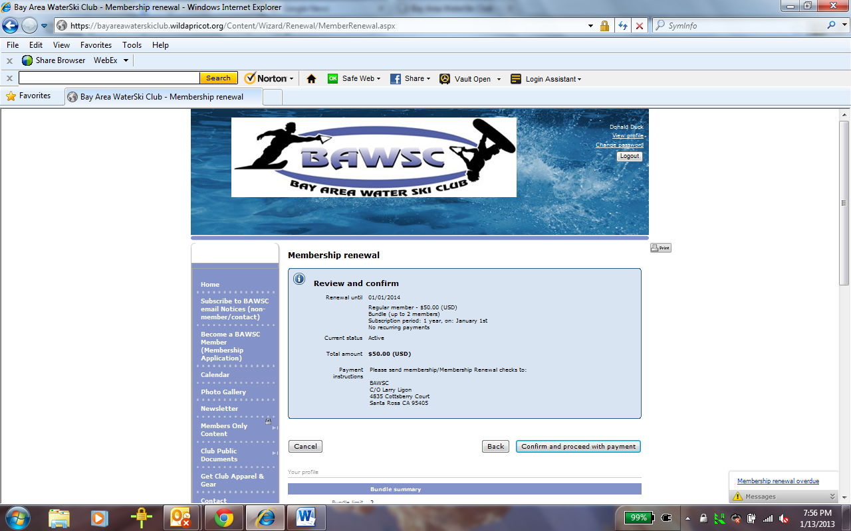

- You will then see a copy of an invoice that has been generated and sent to your email with instructions where to send your membership payment check as in the example screen shot below. At this point you can send your check to the membership chair per the instructions on the screen referencing your invoice number.
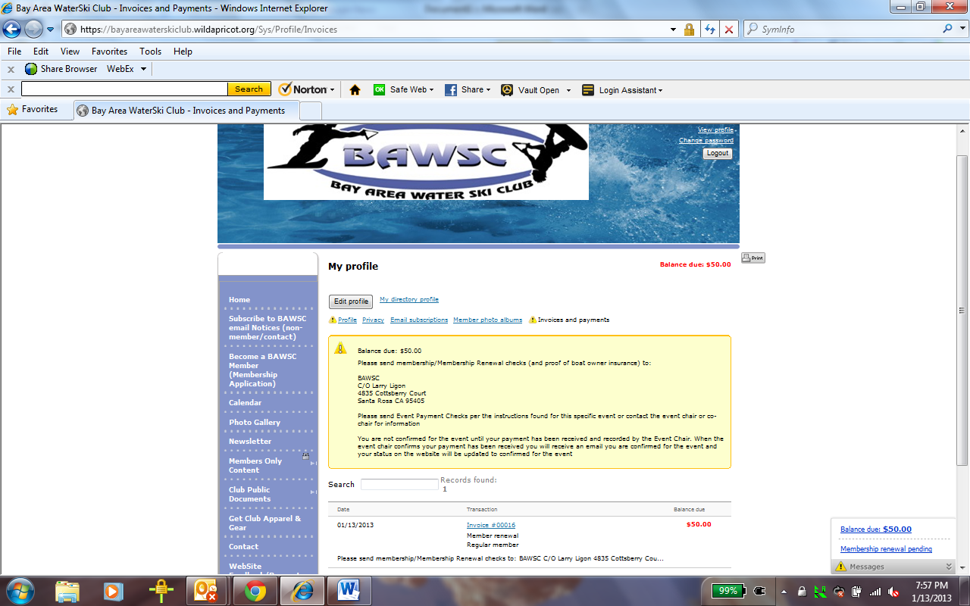
Congratulations you have now completed on membership renewal process. Once your payment has been received the membership chair will record payment and a payment received email will be set and you will continue to have full membership access and privileges to the site.

